# Getting started

<https://our.umbraco.org/documentation/Tutorials/Creating-Basic-Site/Getting-Started>

# Abbreviation

Admin: <https://umbraco.com/Umbraco/>

# How do I create a CMS Page?

## 1. Create Document Type with Template

[Admin](https://umbraco.com/Umbraco/) > Settings > Document Types > Document Type > **Product**

[Admin](https://umbraco.com/Umbraco/) > Settings > Document Types > Master > Home > Permissions -> **Add Child** > **Product**

## 2. Create a CMS Page

[Admin](https://umbraco.com/Umbraco/) > Content > Home > Actions > Create > **Product**

**Note**: Have to select **Document Type** & **Template** for Save and publish as below:

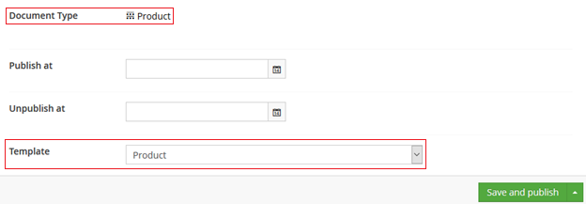

## 3. Create a Master Template

[Admin](https://umbraco.com/Umbraco/) > Settings > Templates > Layout > Create

# How do I change the value of Copyright field in Umbraco CMS?

[Admin](https://umbraco.com/Umbraco/) > > Content -> Home > Copyright

# How do I change the theme of page?

[Admin](https://umbraco.com/Umbraco/) > Settings > Templates > … > Properties > Master template as below:

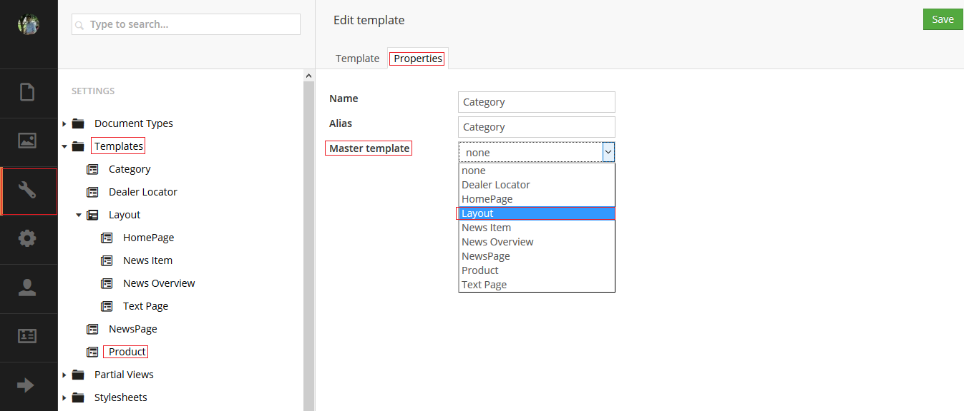

# How do I use logging?

using Umbraco.Core.Logging;

...

LogHelper.Info<HomeController>("Hello from the HomeController.cs.")

# How do I use ApiController?

using System.Web.Mvc;

using Umbraco.Core.Logging;

using Umbraco.Web.WebApi;

using UmbracoCms.Models;

namespace UmbracoCms.Controllers

{

public class CategoryApiController : UmbracoApiController

{

public JsonResult GetCategories()

{

LogHelper.Info<CategoryApiController>("Hello from the CategoryApiController.cs.");

var db = ApplicationContext.DatabaseContext.Database;

var categories = db.Query<umbCategory>("SELECT [category_id],[category_parent_id],[category_name],[description],[picture] FROM umbCategories");

return new JsonResult()

{

Data = categories

};

}

}

}

# How do I use SurfaceController?

using System.Web.Mvc;

using Umbraco.Core.Logging;

using Umbraco.Web.Mvc;

using UmbracoCms.Models;

namespace UmbracoCms.Controllers

{

public class CategorySurfaceController : SurfaceController

{

// GET: /umbraco/surface/CategorySurface/GetCategories

public JsonResult GetCategories()

{

LogHelper.Info<CategorySurfaceController>("Hello from the CategorySurfaceController.cs.");

var db = ApplicationContext.DatabaseContext.Database;

var categories = db.Query<umbCategory>("SELECT [category_id],[category_parent_id],[category_name],[description],[picture] FROM umbCategories");

return Json(categories, JsonRequestBehavior.AllowGet);

}

}

}

# How do I use PartialView?

<https://our.umbraco.org/documentation/Reference/Templating/Mvc/child-actions>

<http://lukealderton.com/blog/posts/2016/february/using-umbraco-route-hijacking-and-posting-to-it/>

# How do I route?

<https://our.umbraco.org/forum/developers/extending-umbraco/46086-UmbracoApiController-No-HTTP-resource-was-found-that-matches-the-request-URI>

# How do I use PetaPoco

public List<umbProduct> GetProducts()

{

List<umbProduct> productList = new List<umbProduct>();

Dictionary<int, umbProduct> dictProducts = new Dictionary<int, umbProduct>();

string connStr = @"Data Source=.\SQLEXPRESS;Initial Catalog=NORTHWND;Integrated Security=True";

string queryStr = "SELECT TOP 10 product_id, name, pricing FROM umbProducts;";

using (SqlConnection sqlConn = new SqlConnection(connStr))

{

SqlCommand cmd = new SqlCommand(queryStr, sqlConn);

try

{

sqlConn.Open();

SqlDataReader reader = cmd.ExecuteReader();

while (reader.Read())

{

Debug.WriteLine("\t{0}\t{1}\t{2}", reader[0], reader[1], reader[2]);

umbProduct newProduct = new umbProduct

{

product_id = (int)reader[0],

name = reader[1].ToString(),

pricing = (double)reader[2]

};

productList.Add(newProduct);

}

reader.Close();

}

catch (Exception ex)

{

Debug.WriteLine(ex.Message);

}

}

return productList;

}

# How do I use ADO.NET

[**http://siempresolutions.co.uk/blog/Extending_Umbraco_Custom_Tree_and_MVC_API_Part_3**](http://siempresolutions.co.uk/blog/Extending_Umbraco_Custom_Tree_and_MVC_API_Part_3)

# How do I call Ajax

## [Umbraco - load content with Ajax](http://stackoverflow.com/questions/6197210/umbraco-load-content-with-ajax)

Yup this is exactly the scenario that Base is used for.

You can find documentation on using base here:

<http://our.umbraco.org/wiki/reference/umbraco-base/simple-base-samples>

For the consumption of base via AJAX then JQuery is the answer.

<http://api.jquery.com/jQuery.ajax/>

Here's a hacked together example (not tested code):

$(document).ready(function ()

{

$(".buttonListener").click(function ()

{

$('div#loading').html('<img src="/images/ajax-loader.gif" />');

$.ajax(

{

url: '/Base/TestAlias/Hello.aspx',

success: function (data, textStatus, XMLHttpRequest)

{

alert(data);

},

error: function (XMLHttpRequest, textStatus, errorThrown)

{

alert("Ka pow!");

}

});

$('div#loading').empty();

return true;

});

});

# How the Umbraco MVC Forms using a Surface Controller?

## Contact Form (with source)

<http://programystic.com/code/umbraco/umbraco-mvc-forms/>

## Contact Form Ajax (with source)

<https://www.systenics.com/blog/creating-an-ajax-enabled-contact-form-in-umbraco-6-with-aspnet-mvc-4-and-twitter-bootstrap/?tag=Umbraco+6>

# Umbraco tutorials

I've got a rapidly growing number of tutorials, all aimed at making Umbraco easy to use for non-developers.

If you're just starting with Umbraco (whether you plan to eventually build your own business site or just want to review Umbraco's features), then you should start with the first course "Getting started with Umbraco".

If you already know how to install Umbraco locally and want to get up to speed with using the Umbraco site editor, then the second course "Umbraco editor essentials" is the place to start. This course cover all the main content editing tasks that you're going to need as a site editor

Finally, if you already know how to install umbraco locally and manage the sitebuilder, and now you want to create a website for your business using Umbraco, My third course 'Build your own Umbraco business site' shows you how to install Umbraco on a  shared hosting account and then install and configure my uBizStart business starter site for your business.

## [Course 1 - Getting started with Umbraco](http://www.uquickstart.com/umbraco-tutorials/getting-started-with-umbraco)

* Step 1 - How to install Umbraco on your local computer
* Step 2 - How to configure Umbraco with a pre-built site.

## [Course 2 - Umbraco editor essentials](http://www.uquickstart.com/umbraco-tutorials/umbraco-editor-essentials)

* Step 1 - How to login to the Umbraco Sitebuilder
* Step 2 - How to add a new Umbraco page
* Step 3 - How to edit an Umbraco page
* Step 4 - How to delete an Umbraco page
* Step 5 - How to move an Umbraco page
* Step 6 - How to re-order Umbraco pages

## [Course 3 - Build your own Umbraco business site](http://www.uquickstart.com/umbraco-tutorials/build-your-own-umbraco-business-site)

* Step 1 - How to choose a domain name
* Step 2 - How to organise Umbraco shared hosting
* Step 3 - How to install umbraco on shared hosting
* Step 4 - How to configure Umbraco for no starter kit
* Step 5 - How to install uBizStart onto your site
* Step 6 - How to customise uBizstart for your business

# JavaScript

## [What does href expression <a href=“javascript:;”></a> do?](http://stackoverflow.com/questions/7755088/what-does-href-expression-a-href-javascript-a-do)

An <a> element is invalid HTML unless it has either an href or name attribute.

If you want it to render correctly as a link (ie underlined, hand pointer, etc), then it will only do so if it has a href attribute.

Code like this is therefore sometimes used as a way of making a link, but without having to provide an actual URL in the href attribute. The developer obviously wanted the link itself not to do anything, and this was the easiest way he knew.

He probably has some javascript event code elsewhere which is triggered when the link is clicked, and that will be what he wants to actually happen, but he wants it to look like a normal <a> tag link.

Some developers use href='#' for the same purpose, but this causes the browser to jump to the top of the page, which may not be wanted. And he couldn't simply leave the href blank, because href=''is a link back to the current page (ie it causes a page refresh).

There are ways around these things. Using an empty bit of Javascript code in the href is one of them, and although it isn't the best solution, it does work.

## [JavaScript function in href vs. onclick](http://stackoverflow.com/questions/1070760/javascript-function-in-href-vs-onclick)

Putting the onclick within the href would offend those who believe strongly in separation of content from behavior/action. The argument is that your html content should remain focused solely on content, not on presentation or behavior.

The typical path these days is to use a javascript library (eg. jquery) and create an event handler using that library. It would look something like:

$('a').click( function(e) {e.preventDefault(); /*your_code_here;*/ return false; } );

## [What is jQuery Unobtrusive Validation?](http://stackoverflow.com/questions/11534910/what-is-jquery-unobtrusive-validation)

**NuGet**

Install-Package Microsoft.jQuery.Unobtrusive.Validation

<http://bradwilson.typepad.com/blog/2010/10/mvc3-unobtrusive-validation.html>

<http://bradwilson.typepad.com/blog/2010/10/mvc3-unobtrusive-ajax.html>

<https://www.pluralsight.com/courses/aspdotnet-mvc3-intro>

Brad Wilson has a couple great articles on [unobtrusive validation](http://bradwilson.typepad.com/blog/2010/10/mvc3-unobtrusive-validation.html) and [unobtrusive ajax](http://bradwilson.typepad.com/blog/2010/10/mvc3-unobtrusive-ajax.html).  
It is also shown very nicely in this [Pluralsight video](http://www.pluralsight.com/courses/aspdotnet-mvc3-intro) in the section on " AJAX and JavaScript".

Basically, it is simply Javascript validation that doesn't pollute your source code with its own validation code. This is done by making use of data- attributes in HTML.

## [Is “jquery.unobtrusive-ajax.js” obsolete?](http://stackoverflow.com/questions/23388813/is-jquery-unobtrusive-ajax-js-obsolete)

**NuGet**

Install-Package Microsoft.jQuery.Unobtrusive.Ajax

jquery.unobtrusive-ajax.js is a Microsoft library for supporting @Ajax.* helpers, this is a plugin that unobtrusively sets up jQuery Ajax.

If you use @Ajax helpers in your code, like [ActionLink](http://msdn.microsoft.com/en-us/library/system.web.mvc.ajax.ajaxextensions.actionlink%28v=vs.118%29.aspx) or [BeginForm](http://msdn.microsoft.com/en-us/library/system.web.mvc.ajax.ajaxextensions.beginform%28v=vs.118%29.aspx), along with updating jQueryyou have to update the Microsoft [jQuery Unobtrusive Ajax](https://www.nuget.org/packages/Microsoft.jQuery.Unobtrusive.Ajax/3.2.3), otherwise you can remove it.

If you remove reference to the jquery.unobtrusive-ajax.js, @Ajax helpers will be working as regular @Html helpers.

How can I know if I still use them?

Try to look for the usages of these methods.

# CSS

## Tabs

<https://johnnyreilly.github.io/jQuery.Validation.Unobtrusive.Native/AdvancedDemo/CustomValidation.html>